Part 1

1. Describe the energy store changes when a rocket firework is lit, goes up in the air and then falls back
to the ground. (4)

……………………………………………………………………………………………………………………………………………………………………
……………………………………………………………………………………………………………………………………………………………………
……………………………………………………………………………………………………………………………………………………………………
……………………………………………………………………………………………………………………………………………………………………
……………………………………………………………………………………………………………………………………………………………………

2. A cyclist is braking hard to avoid a collision.
Describe the energy store changes as the bicycle and rider decelerate to a stop. (3)

……………………………………………………………………………………………………………………………………………………………………
……………………………………………………………………………………………………………………………………………………………………
……………………………………………………………………………………………………………………………………………………………………
……………………………………………………………………………………………………………………………………………………………………

3. When a battery stops working people often say the energy has been used up. Explain why this statement is not
correct. (2)

……………………………………………………………………………………………………………………………………………………………………
……………………………………………………………………………………………………………………………………………………………………

4. The Sankey diagram shows the simple energy store transfers for a car.
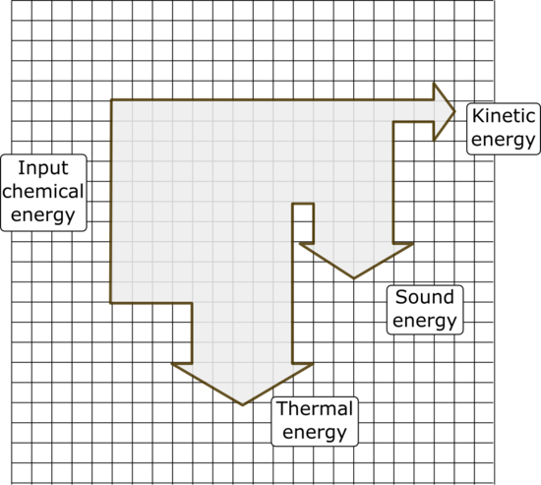

Chemical energy from the petrol = 20 000 J

- Calculate the amount of useful energy
transferred by the engine. (1)

- What is the total amount of “wasted” energy
in the system? (1)

5. An eagle has a mass of 4 kg and is flying at a velocity of 35 m/s. Calculate the kinetic energy of the bird. (3)

……………………………………………………………………………………………………………………………………………………………………
……………………………………………………………………………………………………………………………………………………………………
……………………………………………………………………………………………………………………………………………………………………
……………………………………………………………………………………………………………………………………………………………………

6. A 48 kg person diving off a cliff has 3500 J of stored gravitational potential energy. Calculate the height of the cliff (3)

……………………………………………………………………………………………………………………………………………………………………
……………………………………………………………………………………………………………………………………………………………………
……………………………………………………………………………………………………………………………………………………………………
……………………………………………………………………………………………………………………………………………………………………

Part 2

1. The lift in the world’s tallest building takes 64 s to reach a height of 828 m.
The maximum mass of the lift and passengers is 900 kg.
- Calculate the power of the lift. (3)
……………………………………………………………………………………………………………………………………………………………………
……………………………………………………………………………………………………………………………………………………………………
……………………………………………………………………………………………………………………………………………………………………
……………………………………………………………………………………………………………………………………………………………………
- A service lift in this building is used to move furniture to apartments in the tower.
This lift has a 130 kW motor. If the maximum load for this lift is 2000 kg, how long will it take to reach the top of the building? (3)

……………………………………………………………………………………………………………………………………………………………………
……………………………………………………………………………………………………………………………………………………………………
……………………………………………………………………………………………………………………………………………………………………
……………………………………………………………………………………………………………………………………………………………………

2. The diagram represents the energy transfers for an oil-fired power station.
Generator
Turbine
Water and steam
Oil

Energy transferred as movement
Useful energy out
X
Energy transferred as heat

- What is the useful energy out? (1)

……………………………………………………………………………………………………………………………………………………………………
……………………………………………………………………………………………………………………………………………………………………

- In what form will energy be “wasted” in this process? (1)

……………………………………………………………………………………………………………………………………………………………………
……………………………………………………………………………………………………………………………………………………………………
- What useful energy store is represented by the box labelled X? (1)

……………………………………………………………………………………………………………………………………………………………………
……………………………………………………………………………………………………………………………………………………………………

3. A company sells two types of electric drill.

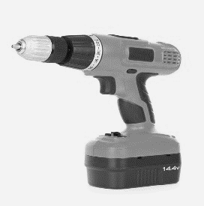
Drill A Drill B
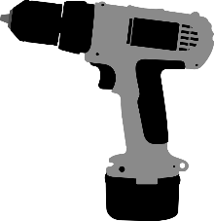

Drill A is a 300 W drill with an output power of 165 W.
Drill B is a 1100 W drill with an output power of 520 W.
Explain which drill is the more efficient at transferring useful energy? (3)

……………………………………………………………………………………………………………………………………………………………………
……………………………………………………………………………………………………………………………………………………………………
……………………………………………………………………………………………………………………………………………………………………
……………………………………………………………………………………………………………………………………………………………………

4. Describe two ways you could increase the efficiency of a household central heating system. (2)
……………………………………………………………………………………………………………………………………………………………………
……………………………………………………………………………………………………………………………………………………………………
……………………………………………………………………………………………………………………………………………………………………

